

ADDRESS BOOK  
JEWELLERY AND COSMETICS

|  |  |  |
| --- | --- | --- |
| SN | ID | STUDENTS |
| 1 | Student1546927 | MUHAMMAD ARHAM . |
| 2 | Student1550980 | MUHAMMAD SAMEER |
| 3 | Student1549508 | AFFAN MAHMOOD |
| 4 | Student1530866 | SAMEER HUSSAIN |

FACULTY : MISS FARIHA SHAFIQ

BATCH CODE : 2402G1

CORDINATOR : MISS IQRA KHAN

SEMISTER : 2 (TERM)

SUBJECT : E PROJECT (ADDRESS BOOK)

E-PROJECT DOCUMENTATION



**TABLE OF CONTENT**

ACKNOWLEDGMENT ABSTRACT CERTIFICATION

* **CHAPTER NO # ONE OVERVIEW**

**1.0 NEED OF PROJECT**

**1.1 PROBLEM DEFINATION**

* **CHAPTER NO # TWODEVELOPMENT AND BACKGROUND**

**2.0 PROJECT DURATION**

**2.1 TASK SHEET**

* **CHAPTER NO # THREE**

**HARDWARE AND SOFTWARE**

**3.0 HARDWARE**

**3.1 SOFTWARE**

* **CHAPTER NO # FOUR CONCLUSION AND REMARKS**

**4.1 SNAP SHOTS**

**4.1 submission checklist**

**4.2 conclusion**

**RELATION**

**The Topic of Our Project Was To Develop a Website For**

**“ADDRESS BOOK”.**

**It’s Made by Using Html, CSS, MySQL and PHP Mainly.  
For Something at Few Points JavaScript and jQuery Is Also Used**

E-PROJECT DOCUMENTATION



**TABLE OF CONTENT**

ACKNOWLEDGMENT

ABSTRACT

CERTIFICATION

**CHAPTER NO # ONE OVERVIEW**

**1.0 NEED OF PROJECT**

**1.1 PROBLEM DEFINATION**

**CHAPTER NO # TWODEVELOPMENT AND BACKGROUND**

**2.0 PROJECT DURATION**

**2.1 TASK SHEET**

**CHAPTER NO # THREE HARDWARE AND SOFTWARE**

**3.0 HARDWARE**

**3.1 SOFTWARE**

TYPES

* ADMIN PANEL
* USER PANEL

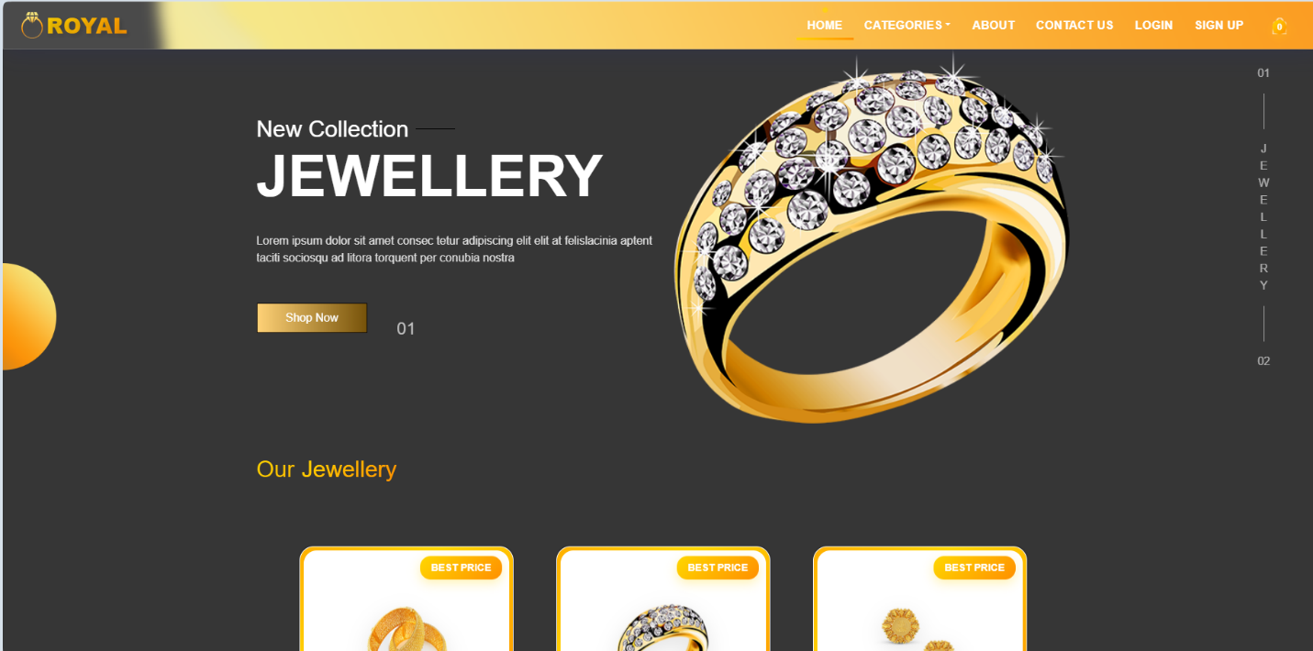

THIS IS THE HOME OF THE USER PANEL  
THIS IS THE HOME INTERFACE OF THE 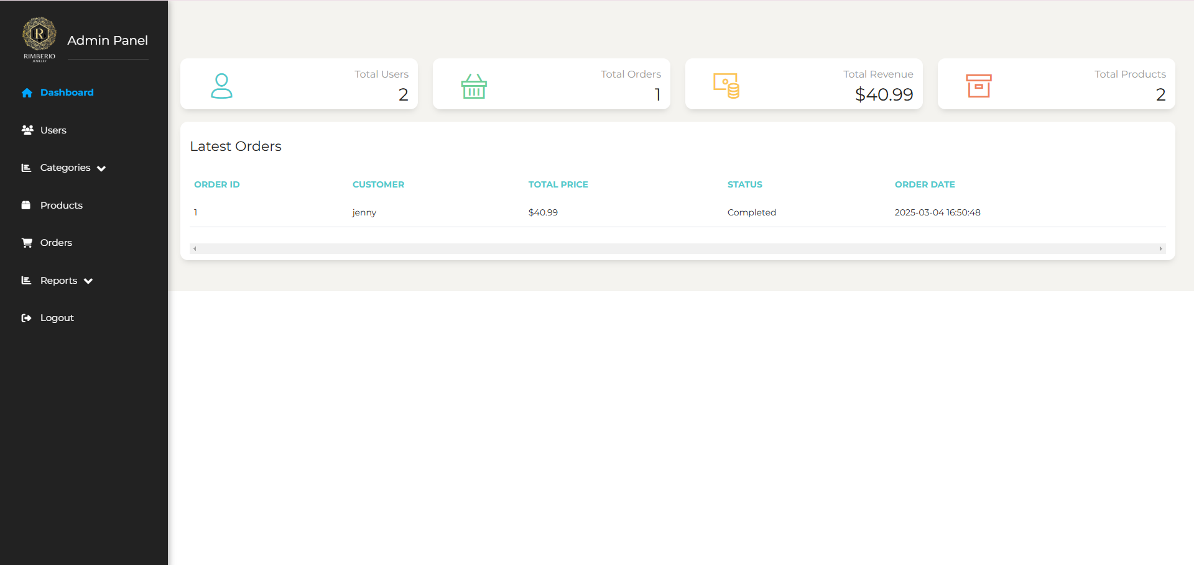ADMIN PANEL